Nama : Muhammad Faiz Al-Dzikro
Nim : 2211523028
PBO - B
Tugas String and Date

- Class Barang
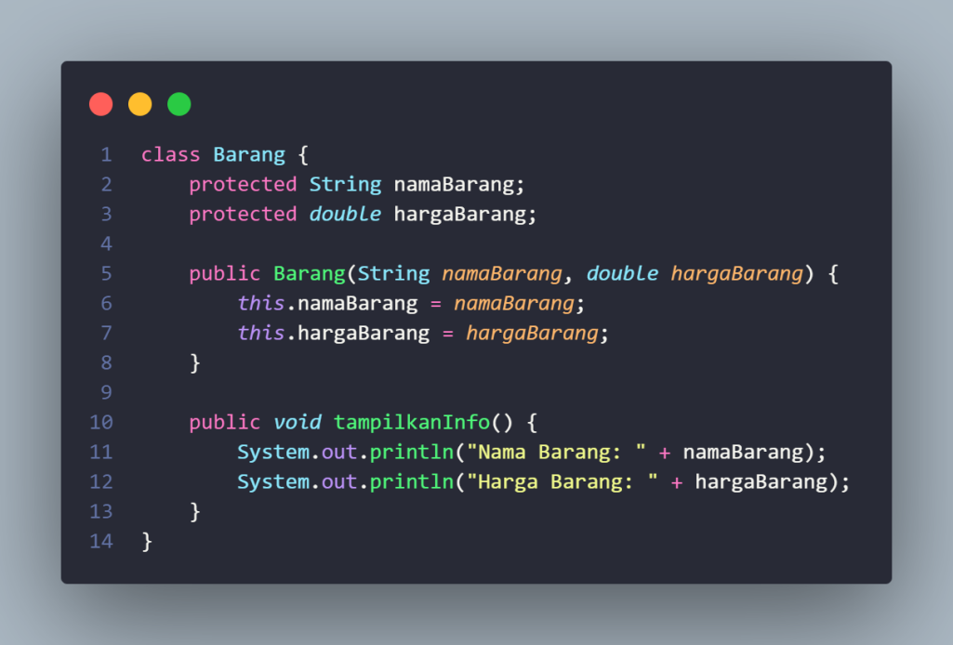

- Class MainTransaksi
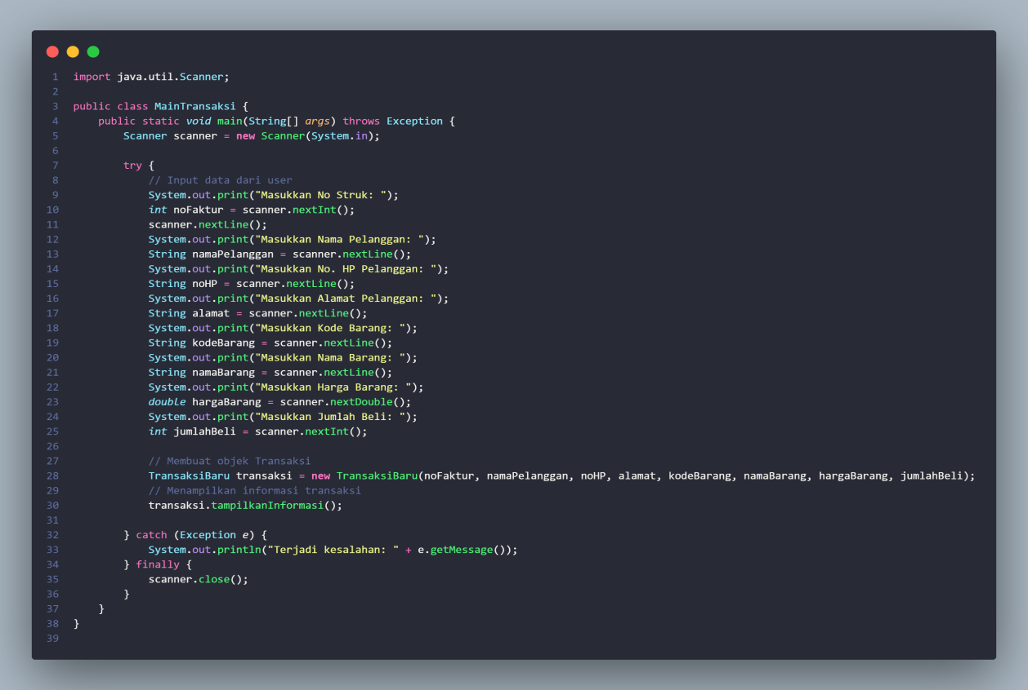

- Class total bayar
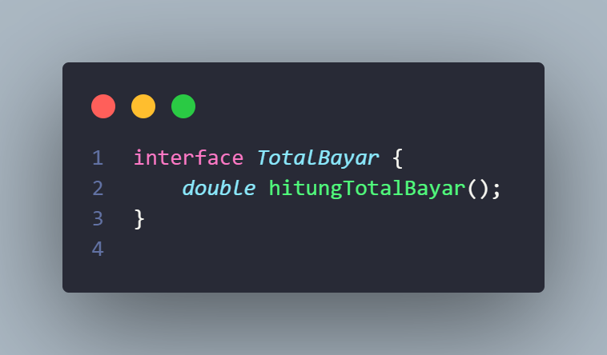

- Class Transaksi baru
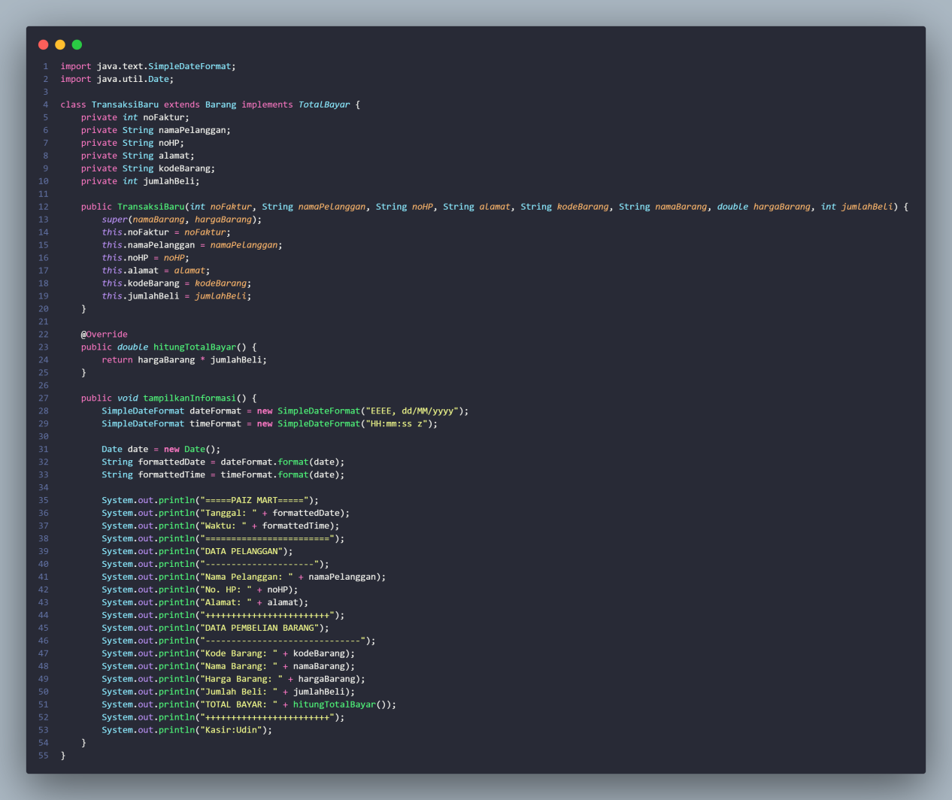

- Output
